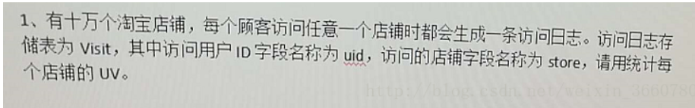

select store,count(distinct uid) as uv from Visit group by store;

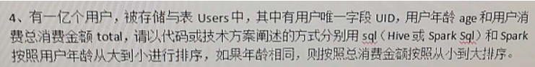

select * from Users order by age desc, total;

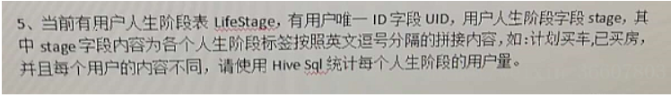

select  stage_someone, count(distinct UID)  from  LifeStage  lateral  view  explode(split(stage,','))  LifeStage_tmp  as stage_someone  group  by  stage_someone;

考点：列转行

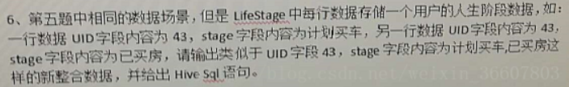

select UID,concat_ws(',',collect_set(stage)) as stages from LifeStage group by UID;

考点：行转列